**Supplementary Materials**

*for*

**Discovery and characterization of naturally occurring chalcones as potent inhibitors against bile salt hydrolases**

Chun-Yu Lia, Hao-Nan Wanga, Guang-Hao Zhua, Li-Lin Songa,b, Xu-Dong Houc, Peng-Chao Huoa, Jie Houc,*, Guang-Bo Gea,*

a Shanghai Frontiers Science Center for Chinese Medicine Chemical Biology; Institute of Interdisciplinary Integrative Medicine Research, Shanghai University of Traditional Chinese Medicine, 1200 Cailun Road, Shanghai 201203, China.

b Dalian Institute of Chemical Physics, Chinese Academy of Sciences, Dalian 116000, China.

c College of Basic Medical Sciences, Dalian Medical University, Dalian, 116044, China.

*Corresponding author.

E-mail address: geguangbo@dicp.ac.cn (G.B. Ge); houjie@dmu.edu.cn (J. Hou)

This file contains one supplementary table and fifteen supplementary figures.

**Table S1.** The inhibitory effects of more than 100 kinds of natural products on lsBSH. All data were shown as mean ± SD of triplicate determinations.

|  |  |  |  |  |  |  |
| --- | --- | --- | --- | --- | --- | --- |
| No. | Class | Compound | MW | Residual Activity (%) | | |
| 1 μM | 10 μM | 100 μM |
| 1 | **Chalcones** | Licochalcone C | 338.40 | 36.62 | 6.82 | 0.61 |
| 2 | Isobavachalcone | 324.37 | 49.90 | 9.81 | 8.55 |
| 3 | Bavachalcone | 324.37 | 62.21 | 17.69 | 10.50 |
| 4 | 4'-*O*-Methylbroussochalcone B | 338.40 | 65.96 | 41.35 | 19.78 |
| 5 | Licochalcone D | 354.40 | 104.68 | 28.00 | 2.06 |
| 6 | Licochalcone A | 338.40 | 90.46 | 38.12 | 9.83 |
| 7 | 2',4'-Dihydroxy-6'-methoxy  -3',5'-dimethylchalcone | 298.34 | 86.08 | 46.85 | 23.99 |
| 8 | Butein | 272.25 | 96.28 | 74.51 | 29.73 |
| 9 | Isoliquiritigenin | 256.26 | 95.00 | 63.26 | 5.46 |
| 10 | Naringenin chalcone | 272.25 | 91.36 | 65.27 | 15.15 |
| 11 | Echinatin | 270.28 | 96.68 | 72.03 | 12.07 |
| 12 | Licochalcone B | 286.28 | 101.67 | 81.88 | 37.45 |
| 13 | Flavokawain A | 314.34 | 93.33 | 75.77 | 75.64 |
| 14 | Isoliquiritin | 418.40 | 109.86 | 113.27 | 86.73 |
| 15 | Neoisoliquiritin | 418.40 | 116.22 | 113.70 | 102.87 |
| 16 | **Flavonoids** | Quercetin | 302.24 | 91.96 | 83.73 | 44.13 |
| 17 | Kaempferol | 286.24 | 90.48 | 49.63 | 39.13 |
| 18 | luteolin | 286.24 | 78.34 | 67.12 | 11.20 |
| 19 | Apigenin | 270.24 | 85.94 | 65.82 | 46.85 |
| 20 | Myricetin | 318.24 | 102.49 | 88.39 | 68.05 |
| 21 | Ampelopsin | 320.25 | 88.15 | 85.03 | 73.58 |
| 22 | Isorhamnetin | 316.26 | 90.00 | 72.77 | 75.00 |
| 23 | Genkwanin | 284.26 | 98.38 | 109.26 | 116.02 |
| 24 | Hesperetin | 302.28 | 82.27 | 31.91 | 4.97 |
| 25 | Pinocembrin | 256.26 | 91.20 | 62.96 | 16.35 |
| 26 | Alpinetin | 270.28 | 87.87 | 74.98 | 51.01 |
| 27 | Formononetin | 268.27 | 112.73 | 110.56 | 93.93 |
| 28 | Genistein | 270.24 | 107.46 | 98.77 | 60.19 |
| 29 | Naringenin | 272.25 | 91.15 | 90.13 | 47.84 |
| 30 | Oroxylin A | 284.26 | 87.72 | 72.01 | 51.56 |
| 31 | Baicalein | 270.24 | 133.06 | 125.33 | 53.69 |
| 32 | Liquiritigenin | 256.25 | 128.83 | 115.75 | 93.07 |
| 33 | Bavachin | 324.37 | 91.18 | 85.44 | 57.15 |
| 34 | Isobavachin | 324.37 | 83.28 | 19.89 | 4.59 |
| 35 | Silymarin | 482.46 | 96.16 | 78.98 | 30.96 |
| 36 | Licoflavonol | 354.35 | 100.65 | 47.62 | 9.21 |
| 37 | Isolicoflavonol | 354.36 | 89.20 | 41.60 | 15.91 |
| 38 | Isoxanthohumol | 354.40 | 99.28 | 86.36 | 34.85 |
| 39 | Biochanin A | 284.26 | 104.87 | 99.08 | 79.69 |
| 40 | Scutellarin | 462.37 | 142.32 | 123.12 | 103.43 |
| 41 | Liquiritin | 418.39 | 120.64 | 123.33 | 117.70 |
| 42 | Neoliquiritin | 418.39 | 118.03 | 116.89 | 115.98 |
| 43 | Liquiritin apioside | 550.51 | 112.40 | 109.52 | 93.72 |
| 44 | Tectorigenin | 300.26 | 102.97 | 98.86 | 63.03 |
| 45 | Neobavaisoflavone | 322.36 | 97.34 | 49.60 | 6.38 |
| 46 | Daidzein | 254.24 | 113.14 | 110.27 | 99.91 |
| 47 | Isoquercitrin | 464.38 | 93.95 | 76.92 | 53.42 |
| 48 | Naringin | 580.53 | 95.45 | 91.02 | 99.55 |
| 49 | Icariin | 676.65 | 104.51 | 90.07 | 84.79 |
| 50 | Calycosin-7-O-β-D-glucoside | 446.40 | 115.31 | 104.57 | 97.32 |
| 51 | Glycitin | 446.41 | 98.37 | 103.69 | 102.69 |
| 52 | **Triterpenoids** | Glycyrrhizic acid | 822.93 | 129.79 | 134.53 | 140.22 |
| 53 | Glycyrrhetinic acid | 470.68 | 110.49 | 109.94 | 66.35 |
| 54 | Betulinic acid | 456.70 | 108.12 | 145.23 | 72.82 |
| 55 | Epibetulinic acid | 456.71 | 108.25 | 99.26 | 137.97 |
| 56 | Oleanolic acid | 456.71 | 117.30 | 115.94 | 83.03 |
| 57 | Oleanonic acid | 454.68 | 121.46 | 87.80 | 28.99 |
| 58 | Ursolic acid | 456.70 | 69.40 | 46.85 | 48.23 |
| 59 | Corosolic acid | 472.71 | 118.91 | 141.61 | 76.20 |
| 60 | Betulonic acid | 454.69 | 138.32 | 143.78 | 136.79 |
| 61 | Celastrol | 450.61 | 127.98 | 98.69 | 71.87 |
| 62 | Toosendanin | 574.62 | 95.45 | 90.48 | 96.07 |
| 63 | (20S)-Protopanaxdiol | 460.00 | 79.10 | 67.37 | 39.87 |
| 64 | 20(R)-Protopanaxatriol | 476.74 | 74.61 | 56.62 | 37.17 |
| 65 | Alisol B | 472.70 | 102.23 | 99.74 | 107.40 |
| 66 | Alisol B 23-acetate | 514.74 | 92.07 | 99.23 | 105.62 |
| 67 | **Coumarins** | Isoglycyrol | 366.36 | 103.94 | 101.98 | 108.33 |
| 68 | Glycycoumarin | 368.37 | 88.24 | 86.58 | 17.51 |
| 69 | Praeruptorin A | 386.40 | 73.77 | 26.62 | 3.13 |
| 70 | Isofraxidin | 222.19 | 90.13 | 83.87 | 46.64 |
| 71 | Xanthotoxin | 216.19 | 80.54 | 63.14 | 22.08 |
| 72 | Xanthotoxol | 202.16 | 74.81 | 73.58 | 40.32 |
| 73 | Bergapten | 216.19 | 66.50 | 32.96 | 14.07 |
| 74 | **Alkaloids** | L-Phenylalanine | 165.19 | 78.76 | 81.93 | 82.12 |
| 75 | Berberine | 336.37 | 98.34 | 91.94 | 83.38 |
| 76 | Epiberberine | 336.36 | 96.28 | 88.24 | 86.46 |
| 77 | Coptisine | 320.32 | 97.95 | 85.25 | 75.22 |
| 78 | Jatrorrhizine | 338.38 | 86.24 | 82.96 | 50.07 |
| 79 | N, N-Dimethyl-L-proline | 144.19 | 99.56 | 100.62 | 100.64 |
| 80 | Palmatine | 352.40 | 99.49 | 97.61 | 93.84 |
| 81 | **Fatty acids** | Propionic acid | 74.08 | 94.79 | 87.76 | 91.25 |
| 82 | Butyric Acid | 88.11 | 97.62 | 98.94 | 89.71 |
| 83 | 2-hydroxybutyric acid | 104.10 | 82.58 | 96.59 | 92.25 |
| 84 | Valeric acid | 102.13 | 84.78 | 83.24 | 83.33 |
| 85 | 3-Methylvaleric acid | 116.16 | 89.59 | 90.01 | 91.43 |
| 86 | Octanoic acid | 144.21 | 104.29 | 105.17 | 103.84 |
| 87 | Lauric acid | 200.31 | 106.26 | 106.54 | 91.05 |
| 88 | Palmitic acid | 256.42 | 109.74 | 107.39 | 98.32 |
| 89 | Oleic acid | 282.46 | 102.46 | 83.67 | 53.49 |
| 90 | Linoleic acid | 280.45 | 103.64 | 76.52 | 33.37 |
| 91 | Arachidonic acid | 304.47 | 106.26 | 52.34 | 5.78 |
| 92 | Dehydroepiandrosterone | 288.42 | 109.62 | 67.72 | 24.75 |
| 93 | **Others** | Arctigenin | 372.41 | 89.64 | 93.39 | 43.87 |
| 94 | Magnolol | 266.33 | 80.18 | 37.70 | 4.89 |
| 95 | Honokiol | 266.34 | 80.02 | 34.19 | 3.80 |
| 96 | Caffeic acid | 180.15 | 100.82 | 95.43 | 102.29 |
| 97 | Phenylpyruvic Acid | 164.16 | 94.07 | 81.44 | 32.88 |
| 98 | D-3-Phenyllactic Acid | 166.17 | 96.95 | 94.35 | 100.02 |
| 99 | L-(-)-3-Phenyllactic acid | 166.17 | 91.29 | 83.14 | 86.93 |
| 100 | Bilobalide | 326.30 | 107.10 | 105.91 | 100.11 |
| 101 | Ginkgolide A | 408.40 | 106.97 | 105.42 | 96.88 |
| 102 | Ginkgolide B | 424.40 | 102.60 | 105.51 | 98.36 |
| 103 | Ginkgolide C | 440.40 | 102.72 | 99.00 | 104.42 |
| 104 | Salicylic acid | 138.12 | 92.21 | 95.22 | 91.79 |
| 105 | Gancaonin I | 354.40 | 72.82 | 18.86 | 20.94 |
| 106 | Phenylacetic acid | 136.15 | 99.45 | 100.57 | 98.48 |
| 107 | 2-Hydroxyphenylacetic Acid | 152.15 | 98.21 | 95.02 | 98.16 |
| 108 | Resveratrol | 228.24 | 78.39 | 76.50 | 67.37 |
| 109 | Ginkgolic acid C13:0 | 320.47 | 81.99 | 23.48 | - |
| 110 | Ginkgolic acid C17:1 | 374.56 | 78.84 | 9.13 | - |
| 111 | **Positive inhibitor** | CAPE | 284.31 | 100.67 | 69.41 | 39.62 |

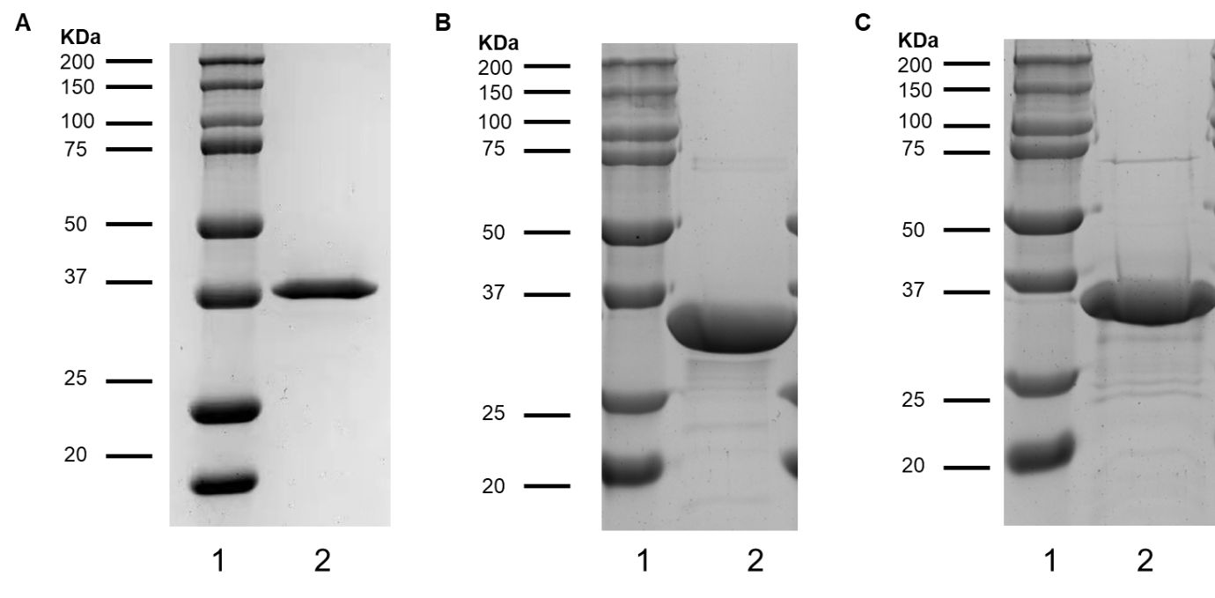

**Fig. S1** SDS-PAGE analysis of lsBSH (A), btBSH (B)and efBSH (C). (1. Marker; 2. The enzyme purified on a Superdex 200 10/300 GL column).



**Fig S2** The synthetic procedure of CA-AMCA.



**Fig.S3** 1H NMR (600 MHz, DMSO-d6) spectrum of CA-AMCA.

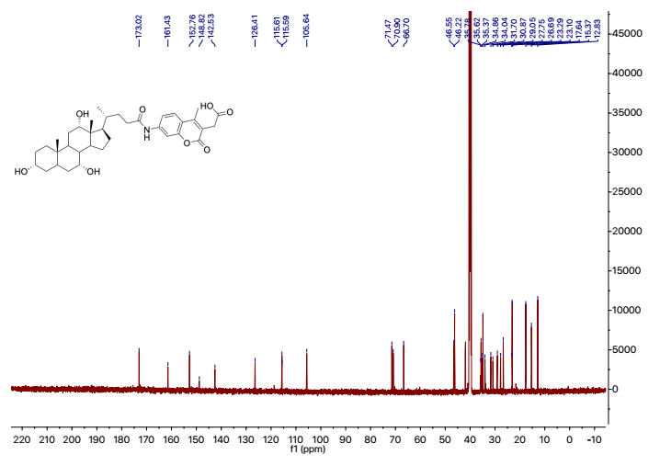

**Fig.S4** 13C NMR (150 MHz, DMSO-d6) spectrum of CA-AMCA.

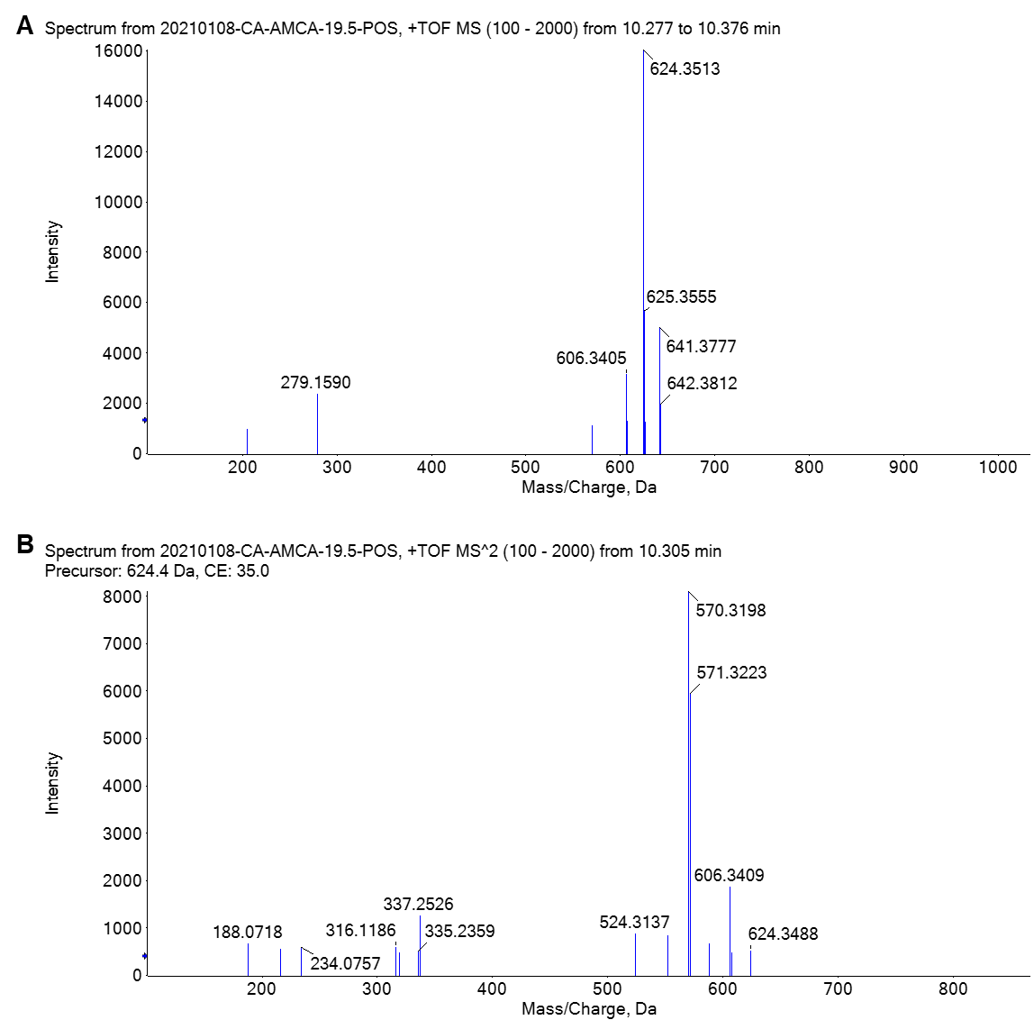

**Fig. S5** MS1 (A) and MS2 (B) spectra of CA-AMCA.



**Fig. S6** Liquid chromatography-fluorescence detection (LC-FD) chromatograms of AMCA and CA-AMCA. (Brown) CA-AMCA only, (Green) AMCA only, (Blue) CA-AMCA was co-incubated with lsBSH (2 μg/mL) at 37 ℃ for 30 min. The fluorescence signals of AMCA and CA-AMCA were recorded using excitation wavelength of 345 nm and emission wavelength of 455 nm.



**Fig. S7** The standard curve of AMCA (the hydrolytic metabolite of CA-AMCA). All data were shown as mean ± SD of triplicate determinations.



**Fig. S8** Enzymatic kinetic plot of lsBSH-catalyzed CA-AMCA hydrolysis. All data were shown as mean ± SD of triplicate determinations.

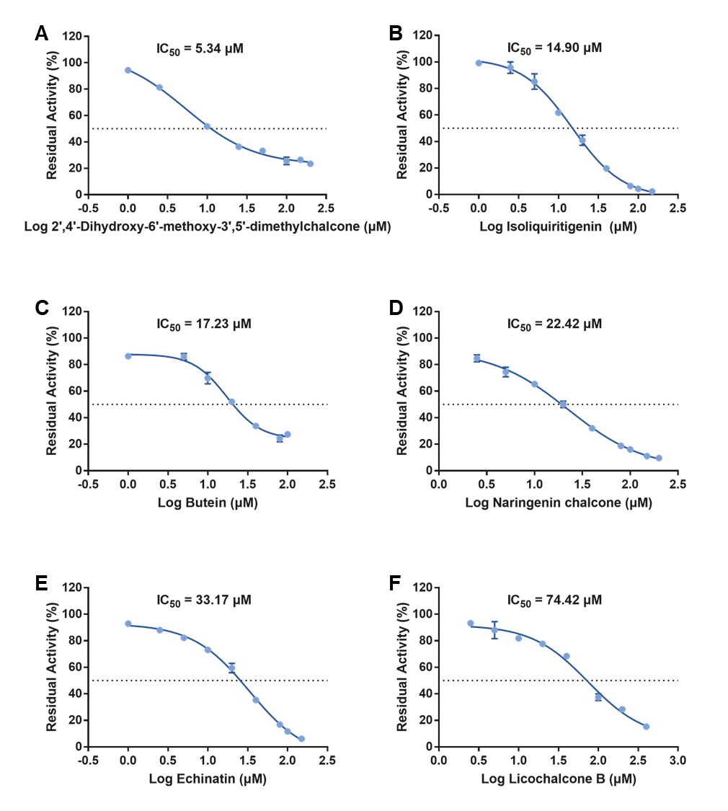

**Fig. S9** The dose-inhibition curves of six natural chalcones (IC50 > 5 μM) against lsBSH-catalyzed CA-AMCA hydrolysis. All data were shown as mean ± SD of triplicate determinations.

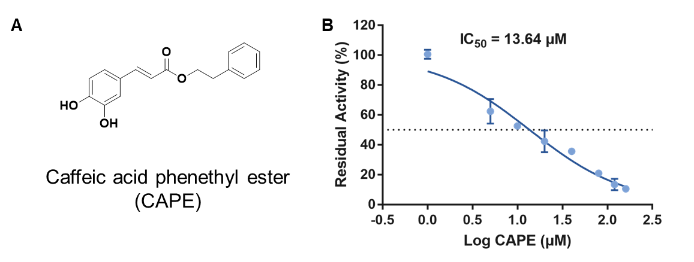

**Fig. S10** (A) The name and structure of CAPE. (B)The dose-inhibition curve of CAPE against lsBSH-catalyzed CA-AMCA hydrolysis. All data were shown as mean ± SD of triplicate determinations.

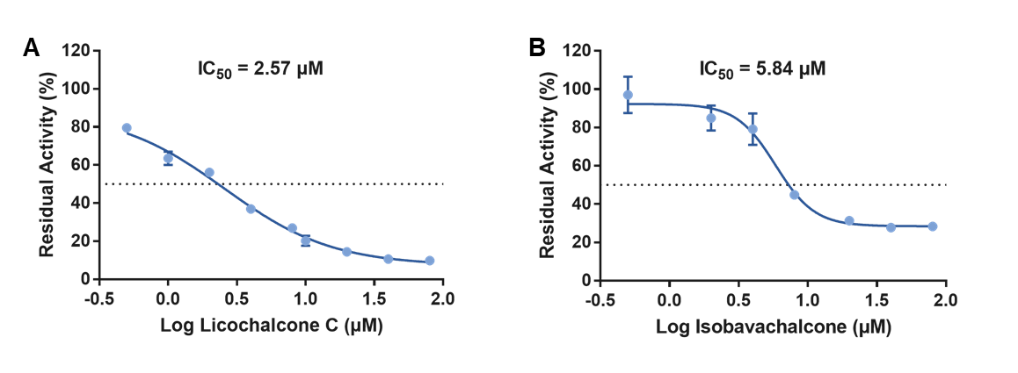

**Fig. S11** The dose-inhibition curve of licochalcone C (A) and isobavachalcone (B) against lsBSH-catalyzed TCA hydrolysis. All data were shown as mean ± SD of triplicate determinations.

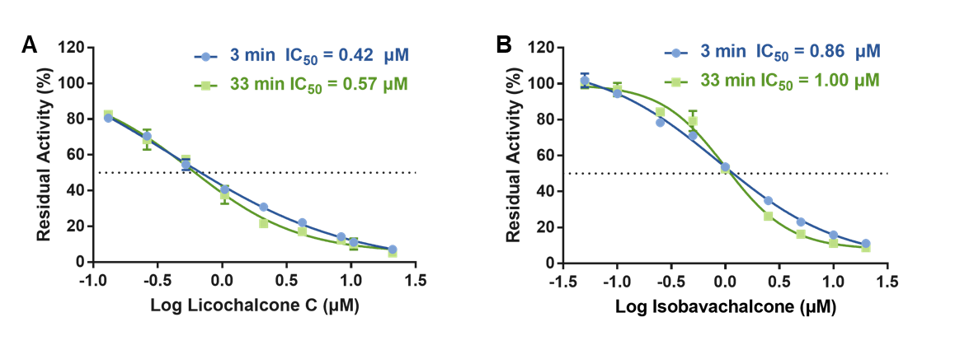

**Fig. S12** The residual activity of lsBSH-catalyzed CA-AMCA hydrolysis in the presence of different concentrations of licochalcone C (A) and isobavachalcone (B) at different pre-incubation times of 3 min and 33 min. All data were shown as mean ± SD of triplicate determinations.

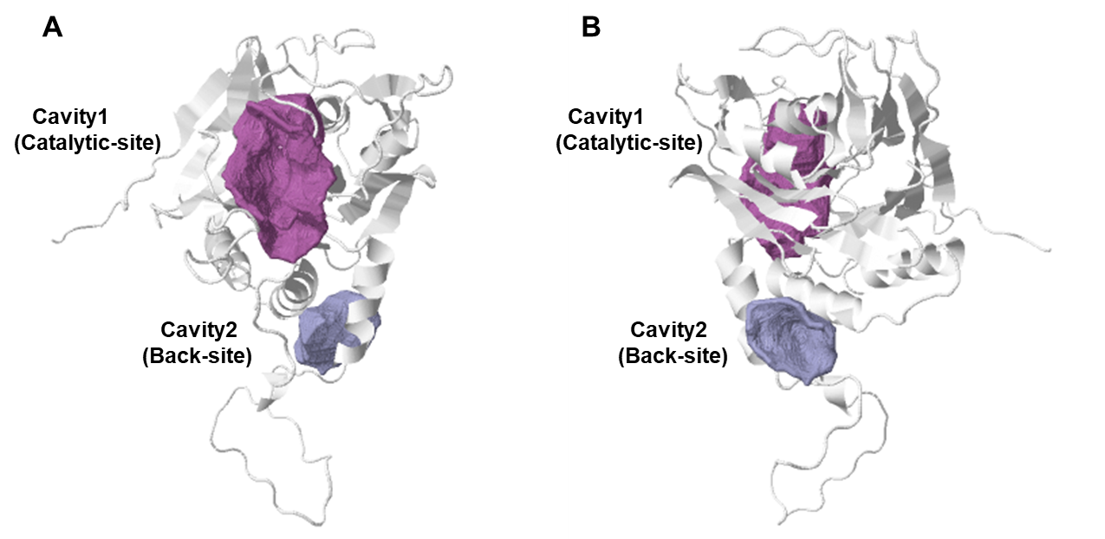

**Fig. S13** Two possible ligand-binding pockets were predicted with CavityPlus. (A) Front view, (B) Back view.

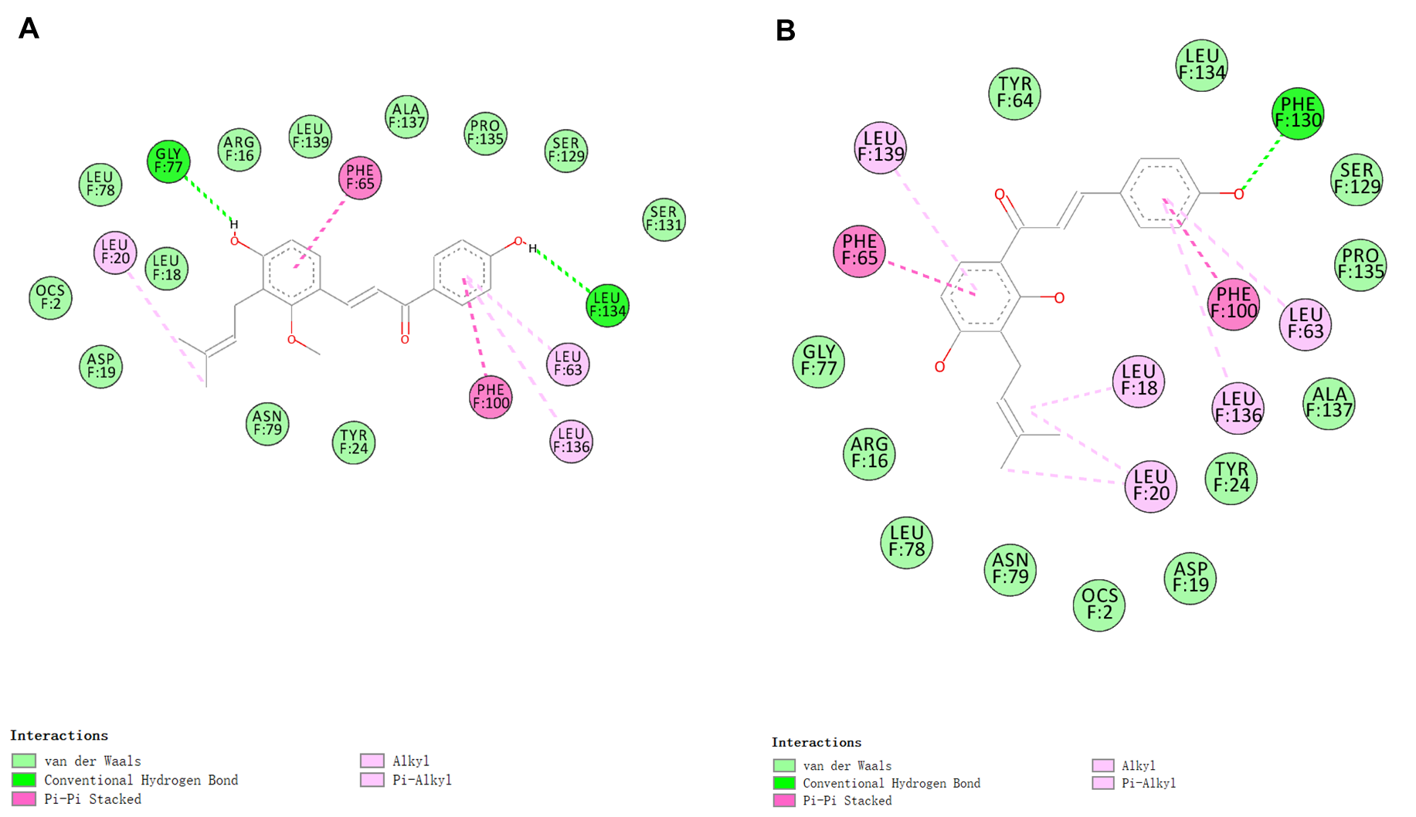

**Fig. S14** The detailed 2D interactions of licochalcone C (A) and isobavachalcone (B) with lsBSH in the catalytic site.

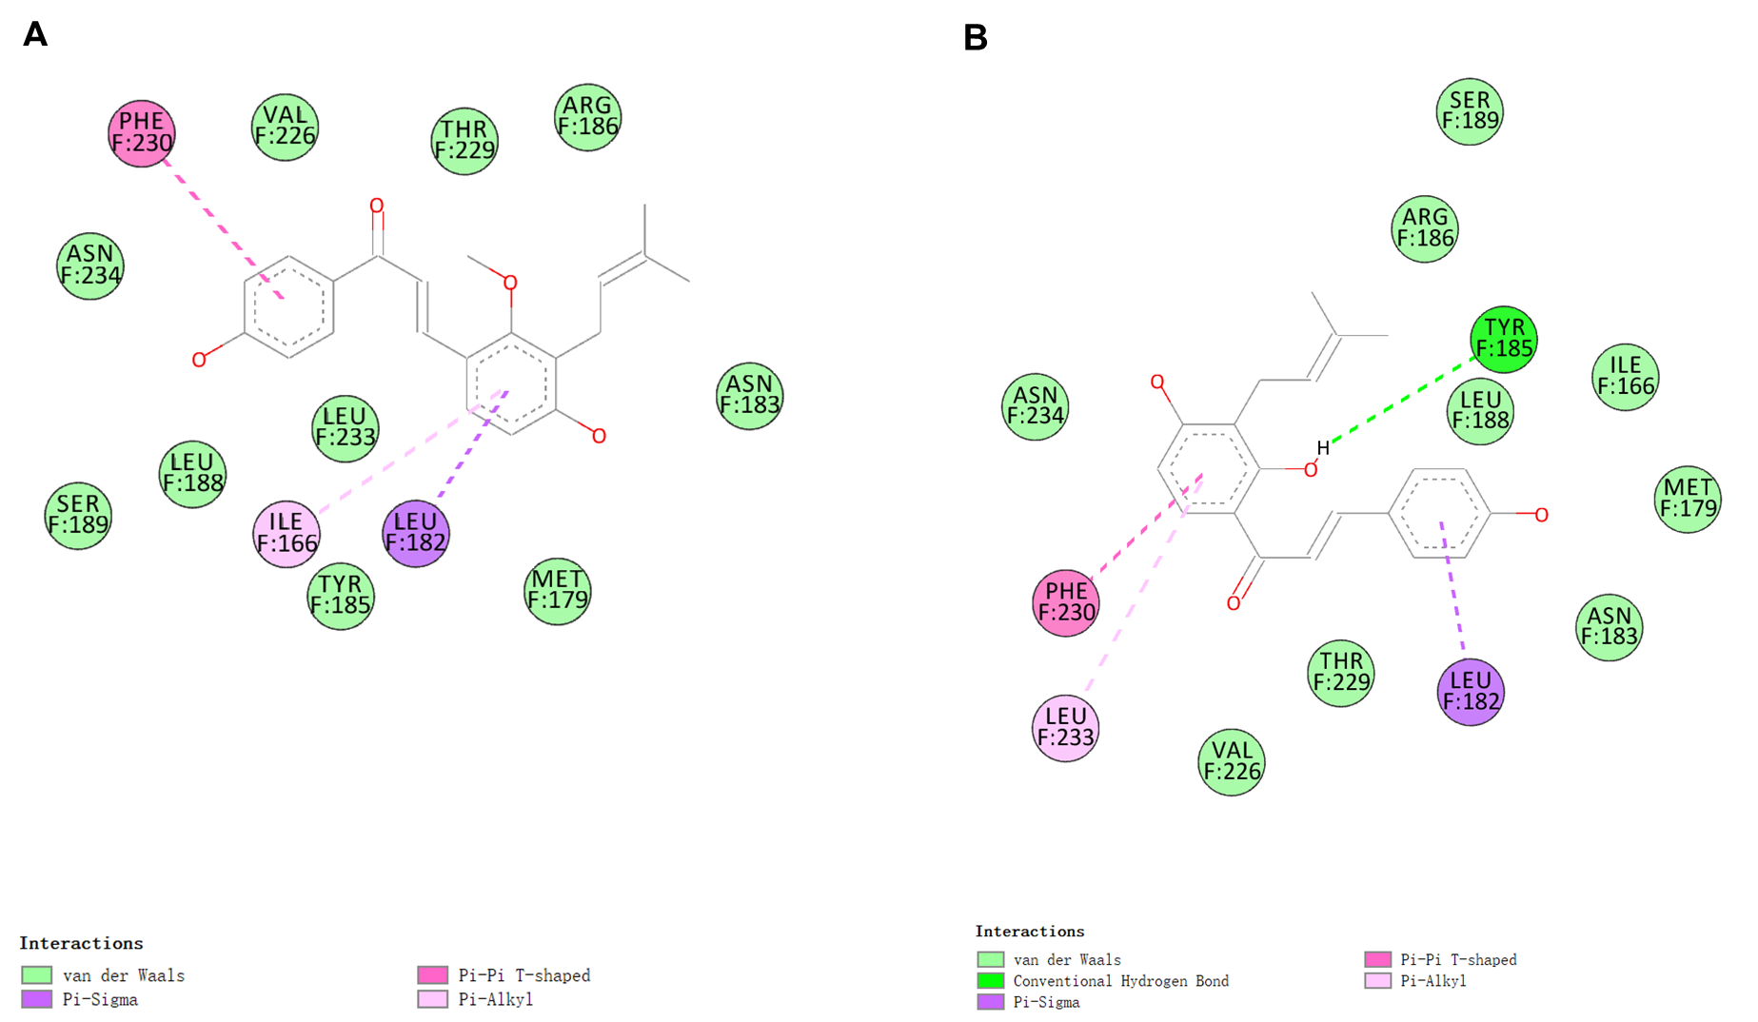

**Fig. S15** The detailed 2D interactions of licochalcone C (A) and isobavachalcone (B) with lsBSH in the back site.